We are going to start with all the system off. No RF signal, no bias DC signals. All off. Just optical signal will be on (emitting)

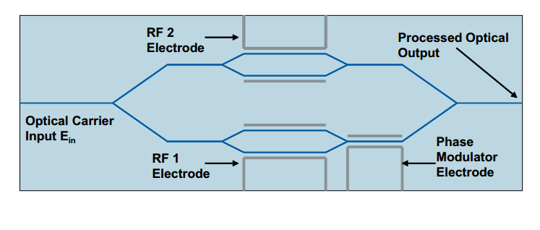

In the Dual Parallel-MachZehnder (DP-MZ) we name: P1 (RF 1 Electrode), P2 (RF 2 Electrode), PP (Phase Modulator Electrode), PG (pin Ground). The function of each one will be:

P1 bias the MZ1

P2 bias the MZ2

PP bias the phase between both MZ1 and MZ2

PG Ground.

The output of the DP-MZ will feed an Optical Spectrum Analyzer (OSA)

1.- Phase bias, PP, will be adjusted until signals from both MZ are in phase. When they both are in phase, the output of the DP-MZ will be maximized in the OSA’s screen.

2.- After signal has been maximized, value of P1 and P2 are tuned in order to minimize the output of the DP-MZ (minimal power in the screen). Both signals from both MZ will be in opposition of phase. System is in minimal configuration.

3.- In order to check system is configured as minimal configuration, Value of PP is tuned and the variation of the signal in the screen of the OSA should be very small (it modifies the relative phase between two very small amplitude signals)

4.- RF generator is switched on. Turning PP the carrier is suppressed.

5.- CONGRATULATIONS! You should have an Optical single side-band signal.

6.- Using the value of PP, the side of the single side band will be changed.